**In The Name of God**

Statistical Inference

HW#3

Spring 1400

Amin Asadi Sarijalu

810196410

Problem 1.

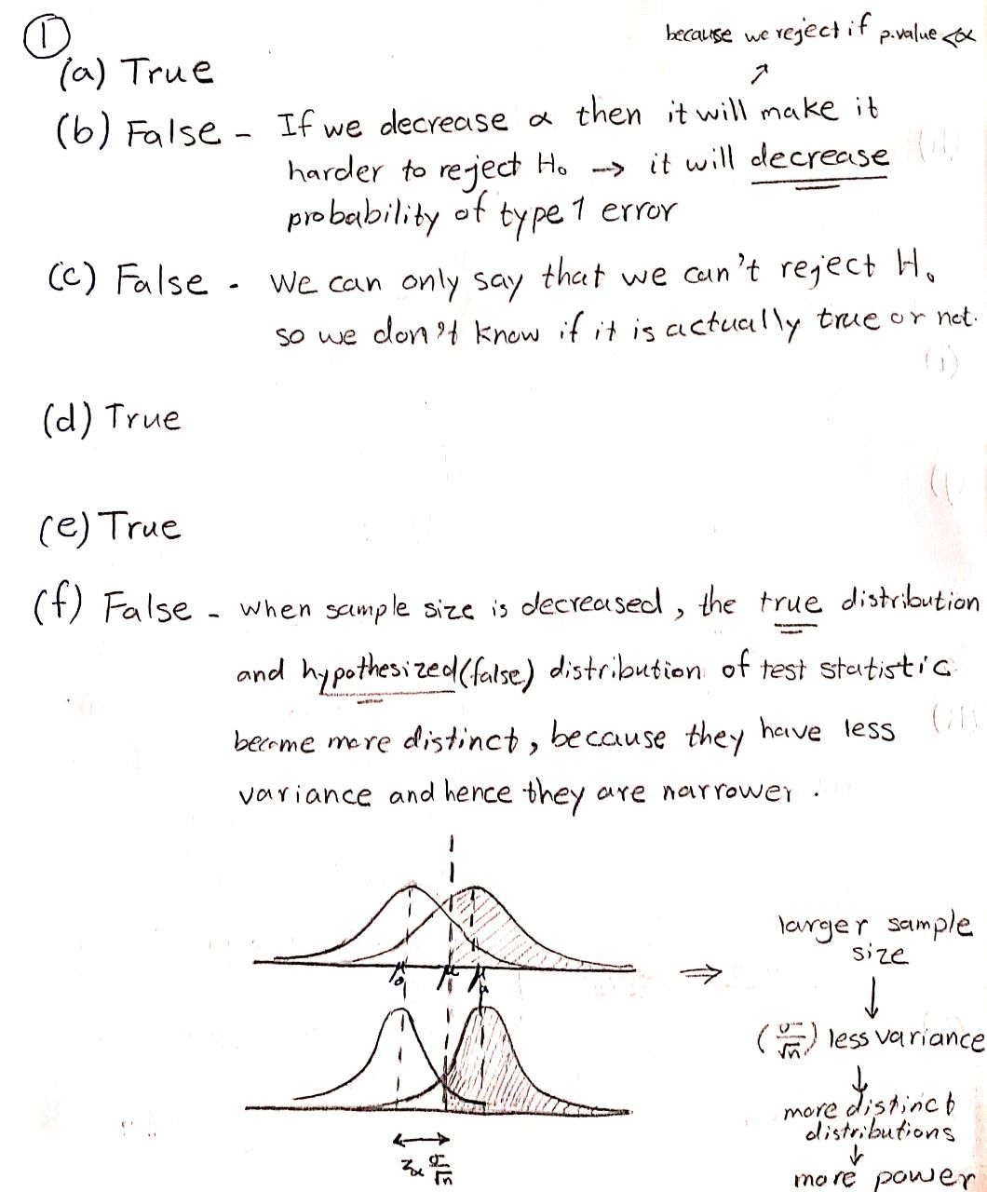

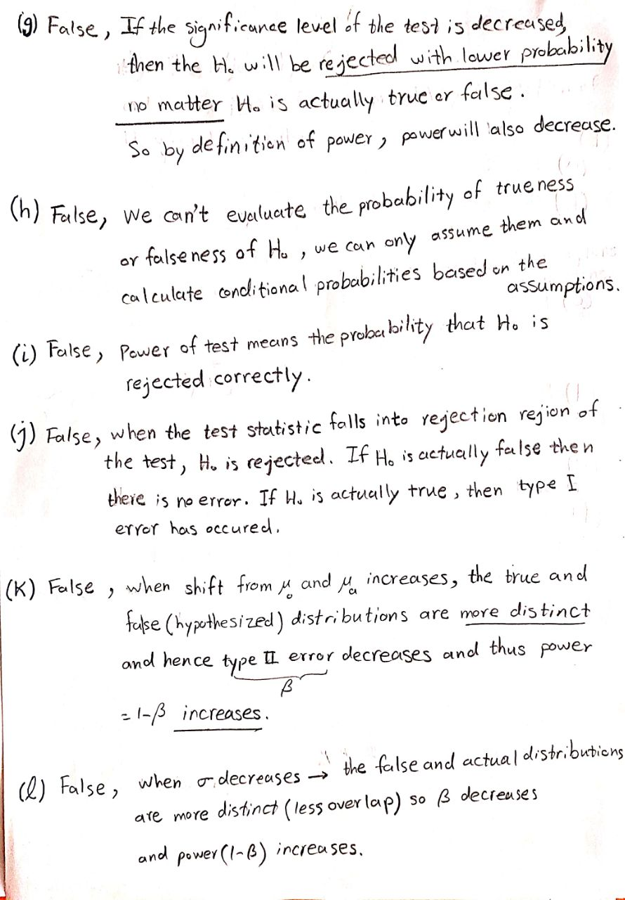

Problem 2.

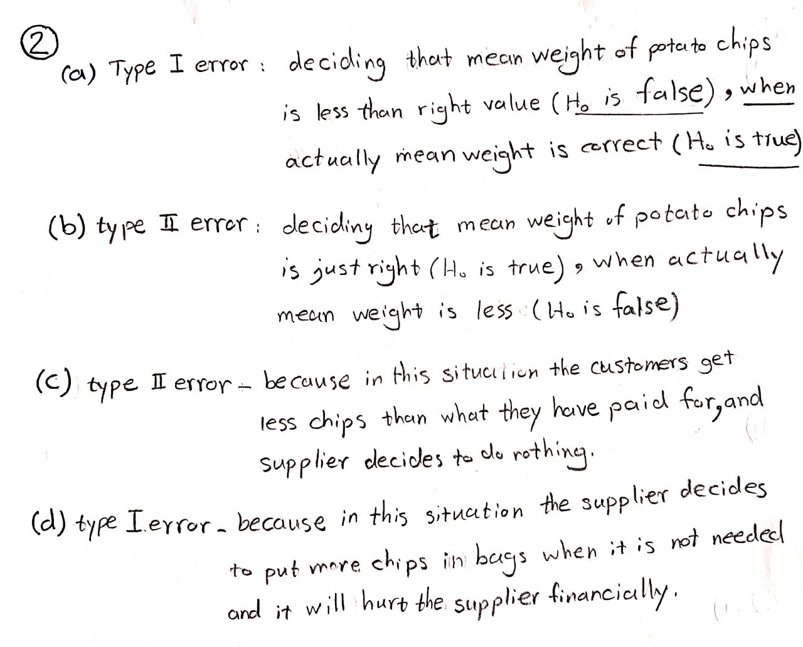

Problem 3.

Central Limit Theorem conditions are satisfied:

* Randomness ---> Independence,
* n = 50 > 30

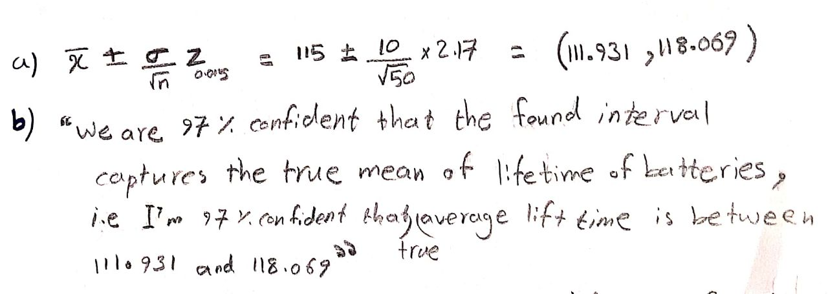

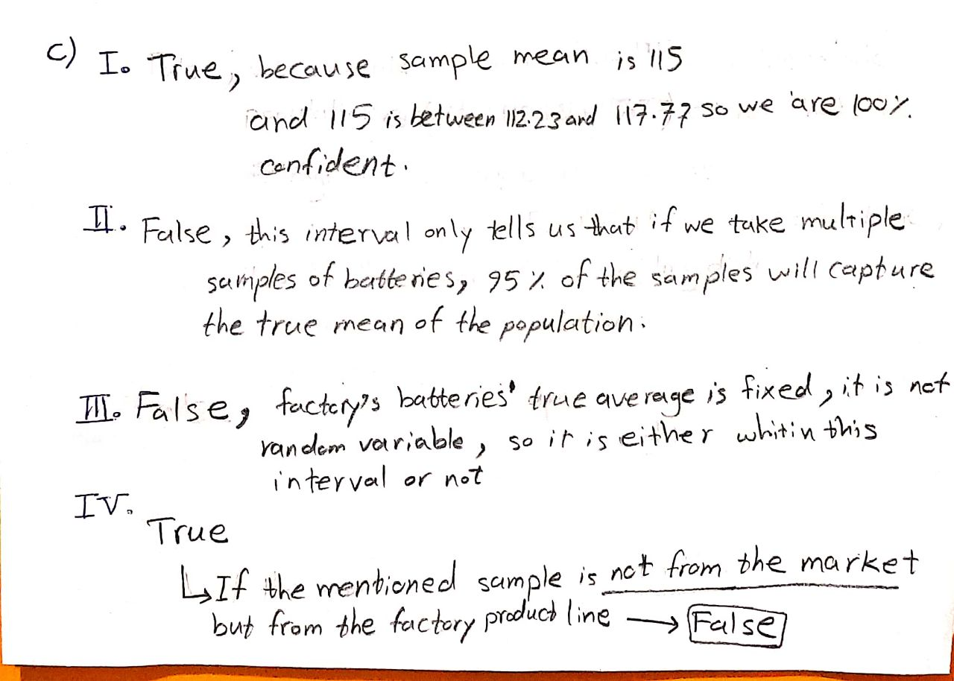

Problem 4.

Central Limit Theorem conditions are satisfied:

* Randomness ---> Independence,
* There are at least 10 successes and 10 failures in the sample(np , n(1-p) >= 10)

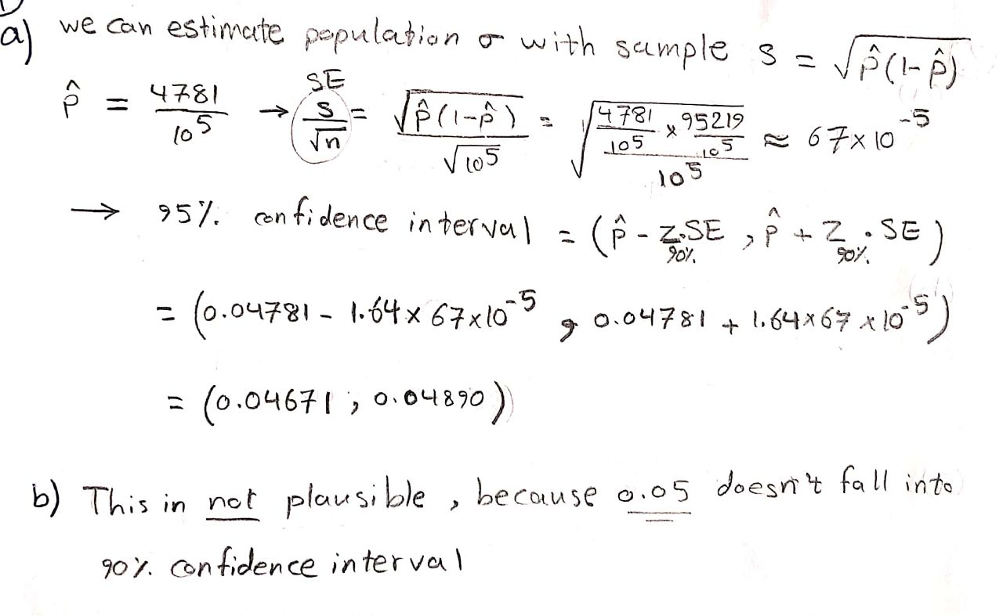

Problem 5.

Central Limit Theorem conditions are satisfied:

* Randomness ---> Independence,
* N1 = 30, N2 = 32 ----> N1, N2 >= 30

a.

**code:**

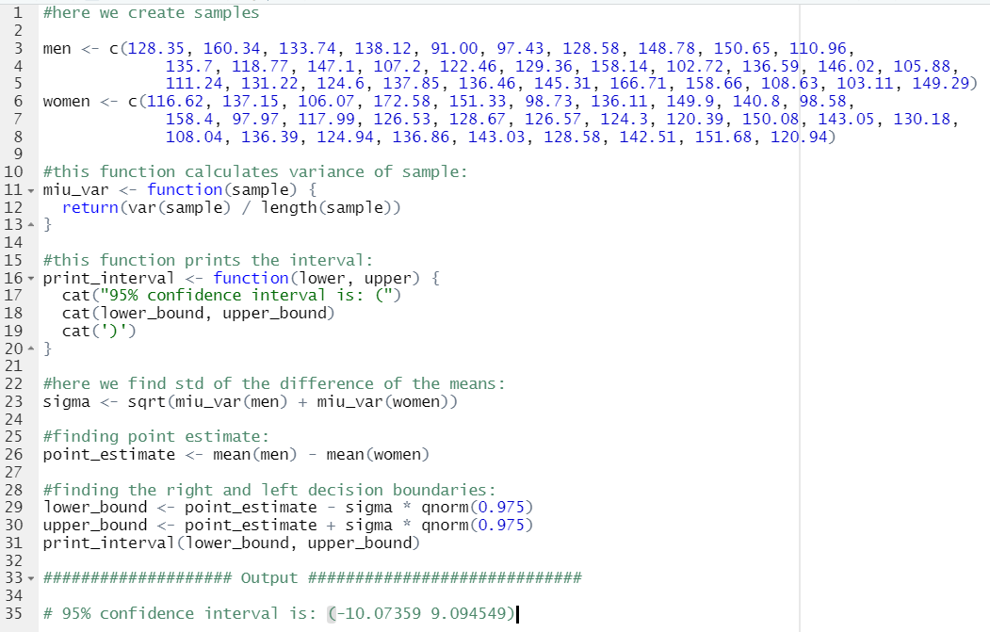

**output:**

95% confidence interval is: (-10.07359 9.094549)

Interpretation:

Here I give two interpretations which are equivalent:

1. In repeated sampling, this method of finding 95% confidence intervals, produces intervals that capture the true difference of the means of the two groups in 95% of the samples.
2. We are 95% confident that this interval captures the true difference of the means of the two groups, i.e., We are 95% confident that the true difference of the means of the two groups is between -10.07359 and 9.094549.

b.

because 0 doesn’t fall into the interval, we can’t reject H0 so we don’t have sufficient evidence to conclude that there is a difference between the means of the two groups.

Problem 6.

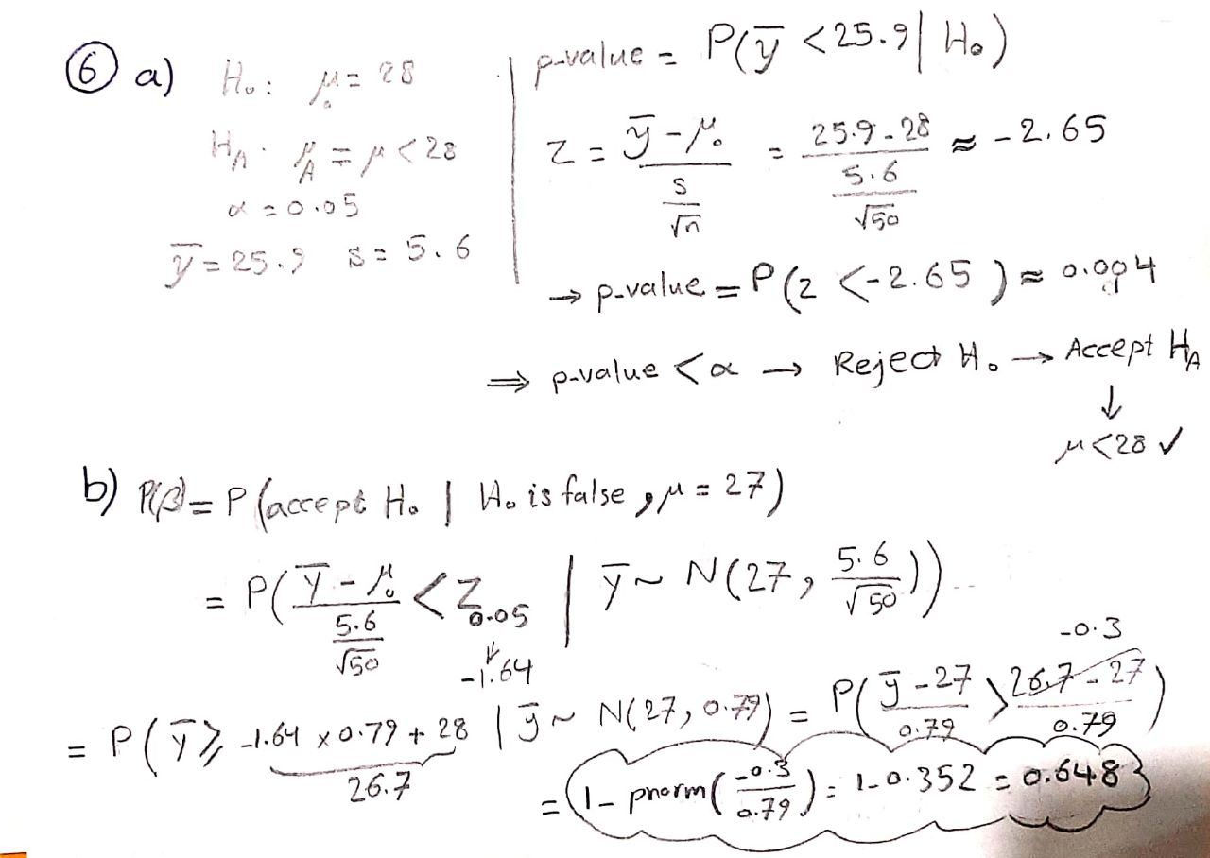

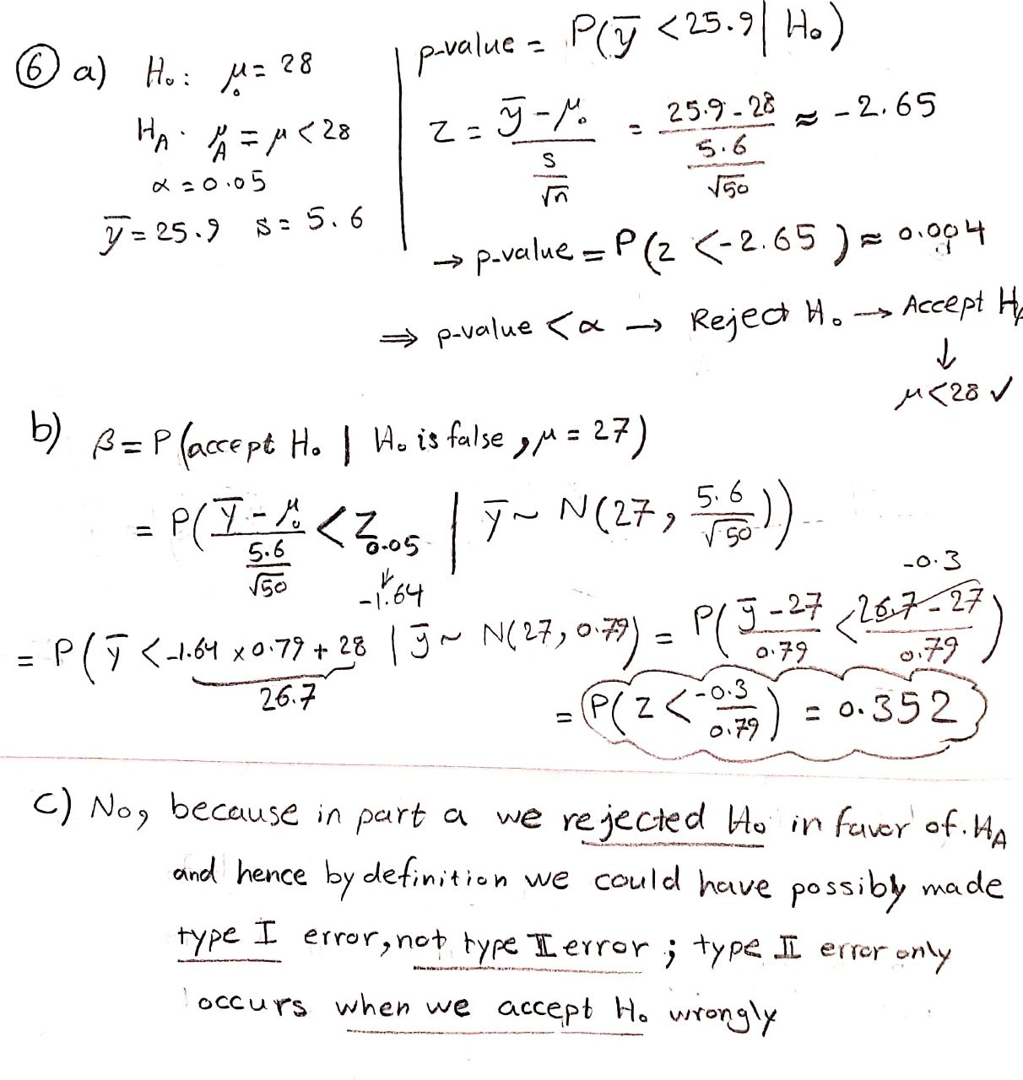

Problem 7.

Codes:

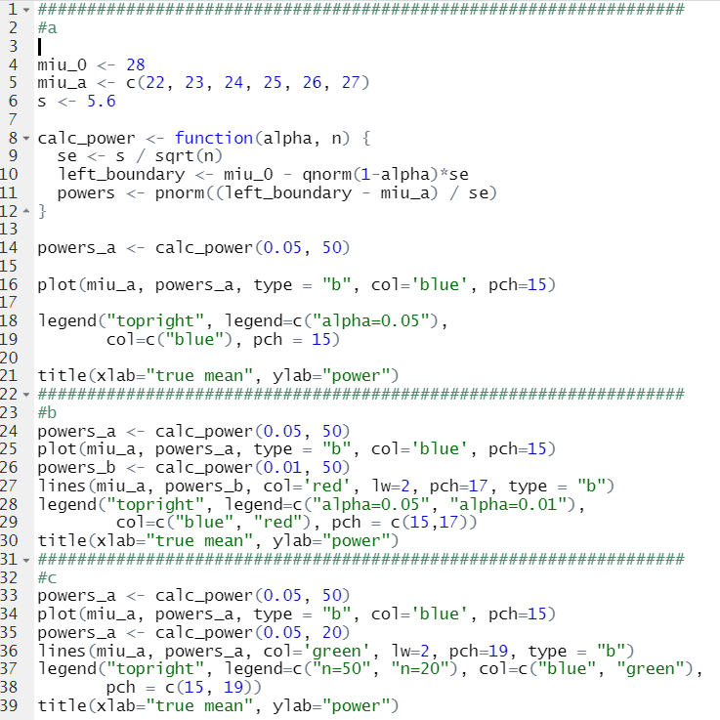

a.

output:

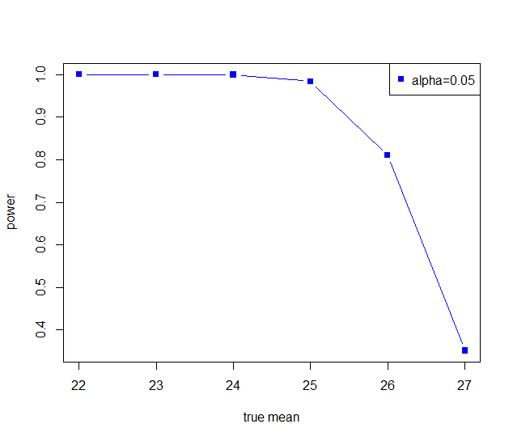

Interpretation:

The closer the true mean to the hypothesized mean(28) , the smaller the power. This is because when true mean is closer to the hypothesized mean, it is more difficult(has smaller probability) to reject H0 and hence by definition, power is smaller.

b.

output:

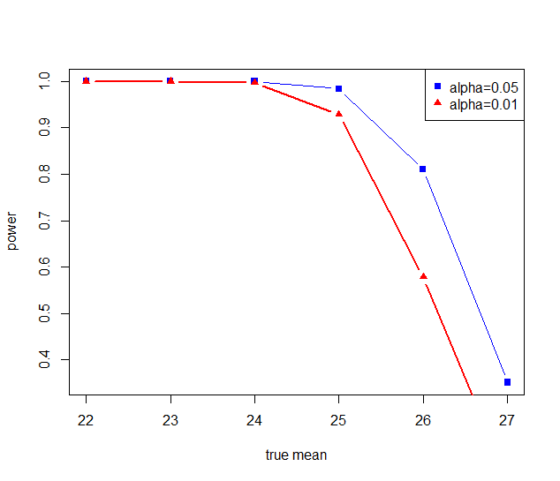

Interpretation:

When alpha is larger, power is also larger. This is because when alpha is larger, H0 is rejected with more probability, and hence by definition, power is larger.

c:

output:

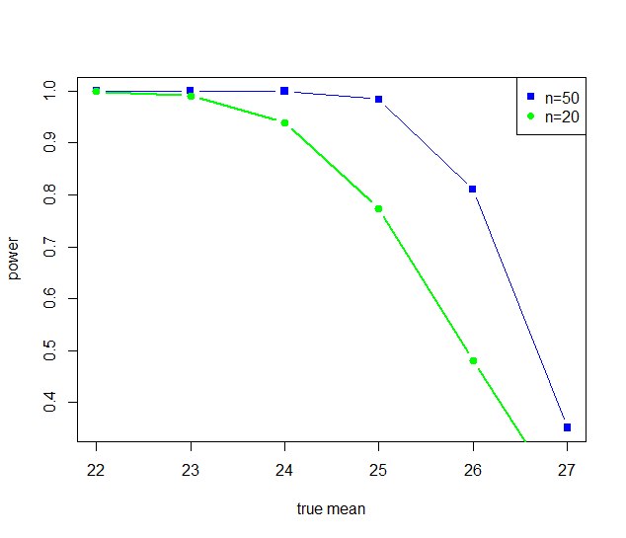

Interpretation:

Larger sample size ---> less variance ---> true and hypothesized distributions are more distinct ---> power is larger

Problem 8.

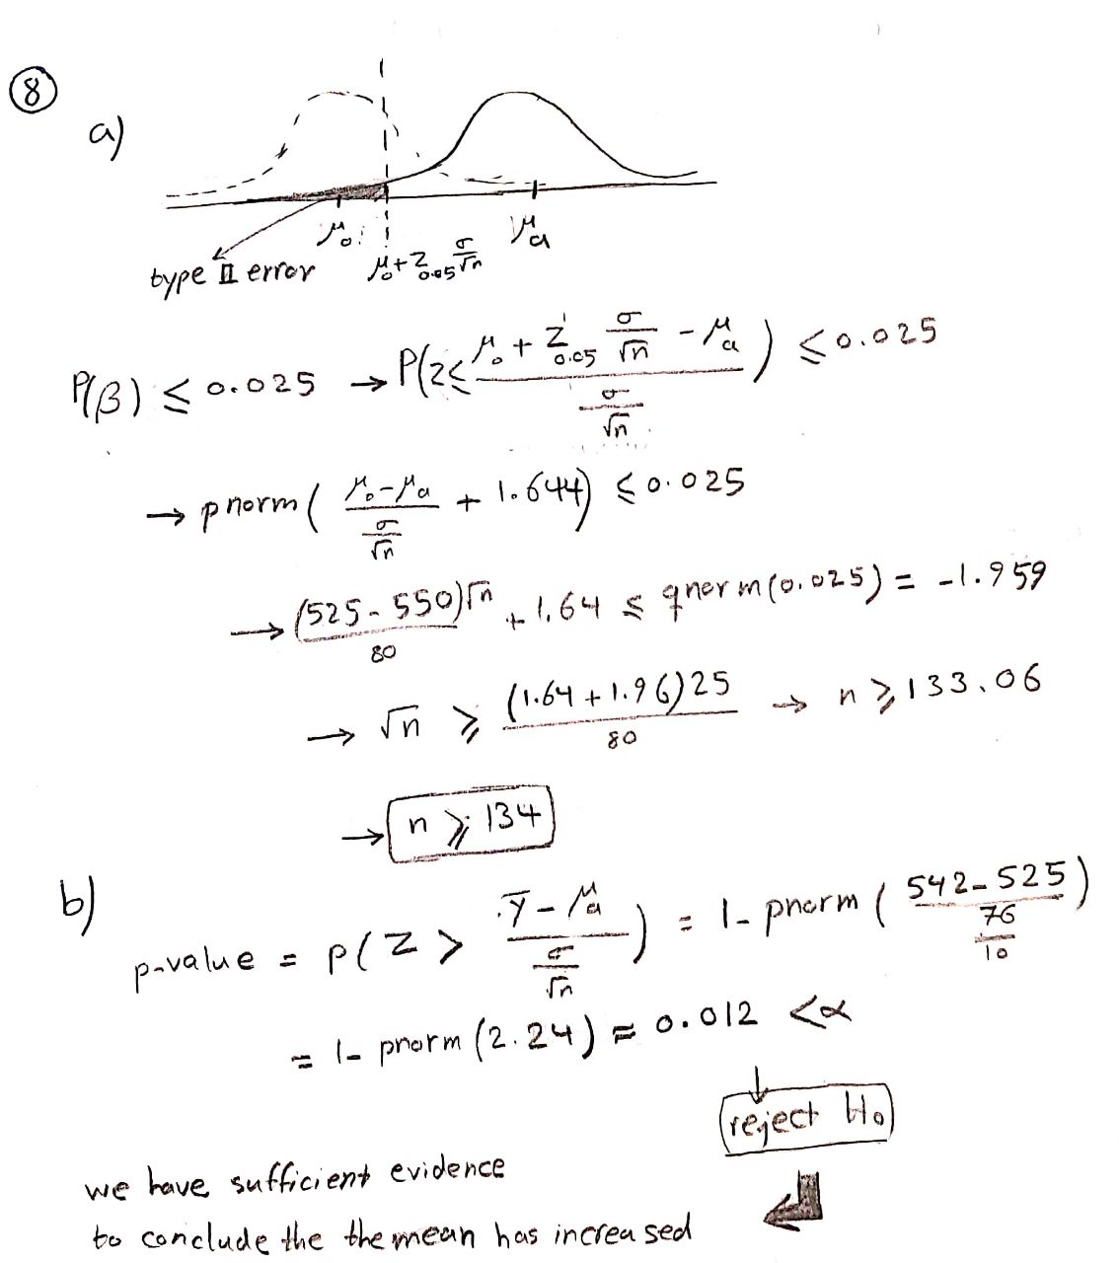

Problem 9.

